Direct aid program – Tonga

Submission guidelines 2024-2025

Photo:Australia's Direct Aid Program co-funded for Houma Vava’u Light House for Strong Women project 2024

## What is the Direct aid program (DAP)?

The Direct Aid Program (DAP) is a competitive small grants program funded by the Australian Aid program, managed by the Australian High Commission in Nuku’alofa. The DAP invites proposals **up to 15,000 pa’anga** that demonstrate a strong benefit to local communities and align with the priority areas of the Australian Aid program in Tonga. These priorities include benefits to;

|  |  |
| --- | --- |
| * people with disabilities * women and girls * income generation and livelihoods * human rights | * environment and climate change * community health * arts and culture * youth and social inclusion |

If you wish to discuss your proposal before submitting, please make an appointment with the DAP coordinator to discuss. You can contact them by phone (20411) or email ([daptonga@dfat.gov.au](mailto:daptonga@dfat.gov.au))

## Key dates for DAP 2024-25

|  |  |  |  |  |
| --- | --- | --- | --- | --- |
|  | **ROUND 1** | **ROUND 2** | **ROUND 3** | **ROUND 4** |
| **Applications Open** | 23 July 2024 | 28 Oct 2024 | 17 Feb 2025 | 22 April 2025 |
| **Applications Close** | 6 August 2024 | 8 Nov 2024 | 28 Feb 2025 | 2 May 2025 |

## How to apply

To apply for a DAP Grant (15,000 pa'anga or less):

1. Go to <https://manage.smartygrants.com.au/signup> to register an account on the Smartygrants online system. If you can’t access the application online, you may collect a hardcopy from the Australian High Commission, Salote Road, Nuku’alofa.

2. Answer each application question according to the instructions provided. Please contact the DAP Coordinator at [daptonga@dfat.gov.au](mailto:daptonga@dfat.gov.au) if you have any questions about the DAP application process.

3. Submit your application electronically to [daptonga@dfat.gov.au](mailto:daptonga@dfat.gov.au) or hard in a copy to the Australian High Commission.

#### In recent years, the DAP in Tonga has supported projects including:

* tapa extracting machines for Houma Town Council, Tongatapu
* Canteen and Cooking project for Setitaia Youth, ‘Eua
* Feletoa Hall Refurbishment project, Vava’u
* Nimamea’a project for the Langafonua ‘a Fafine ‘Uiha, Ha’apai
* Project Parvo for the Tonga Animal Welfare Society, Tongatapu

#### To strengthen your application, you should consider:

* How will you maximise the number of people that will benefit from your project?
* Can the community contribute to support the project (land, material, labour or resources)?
* How can the project continue to provide a benefit to the community after the funding has been spent?

#### What types of projects are **not** eligible under the DAP?

* issuing cash grants, cash prizes, grants programs, micro-credit schemes, commercial ventures, and payment for food caterings/meals
* buying livestock, vehicles, lawnmowers, weed eaters, water tanks or fences for individual households
* improvements to an individual’s house or land
* overseas travel

routine and/or recurring running costs and administrative expenses including rent and utility costs, spare parts, routine maintenance and reports, or staff salaries.

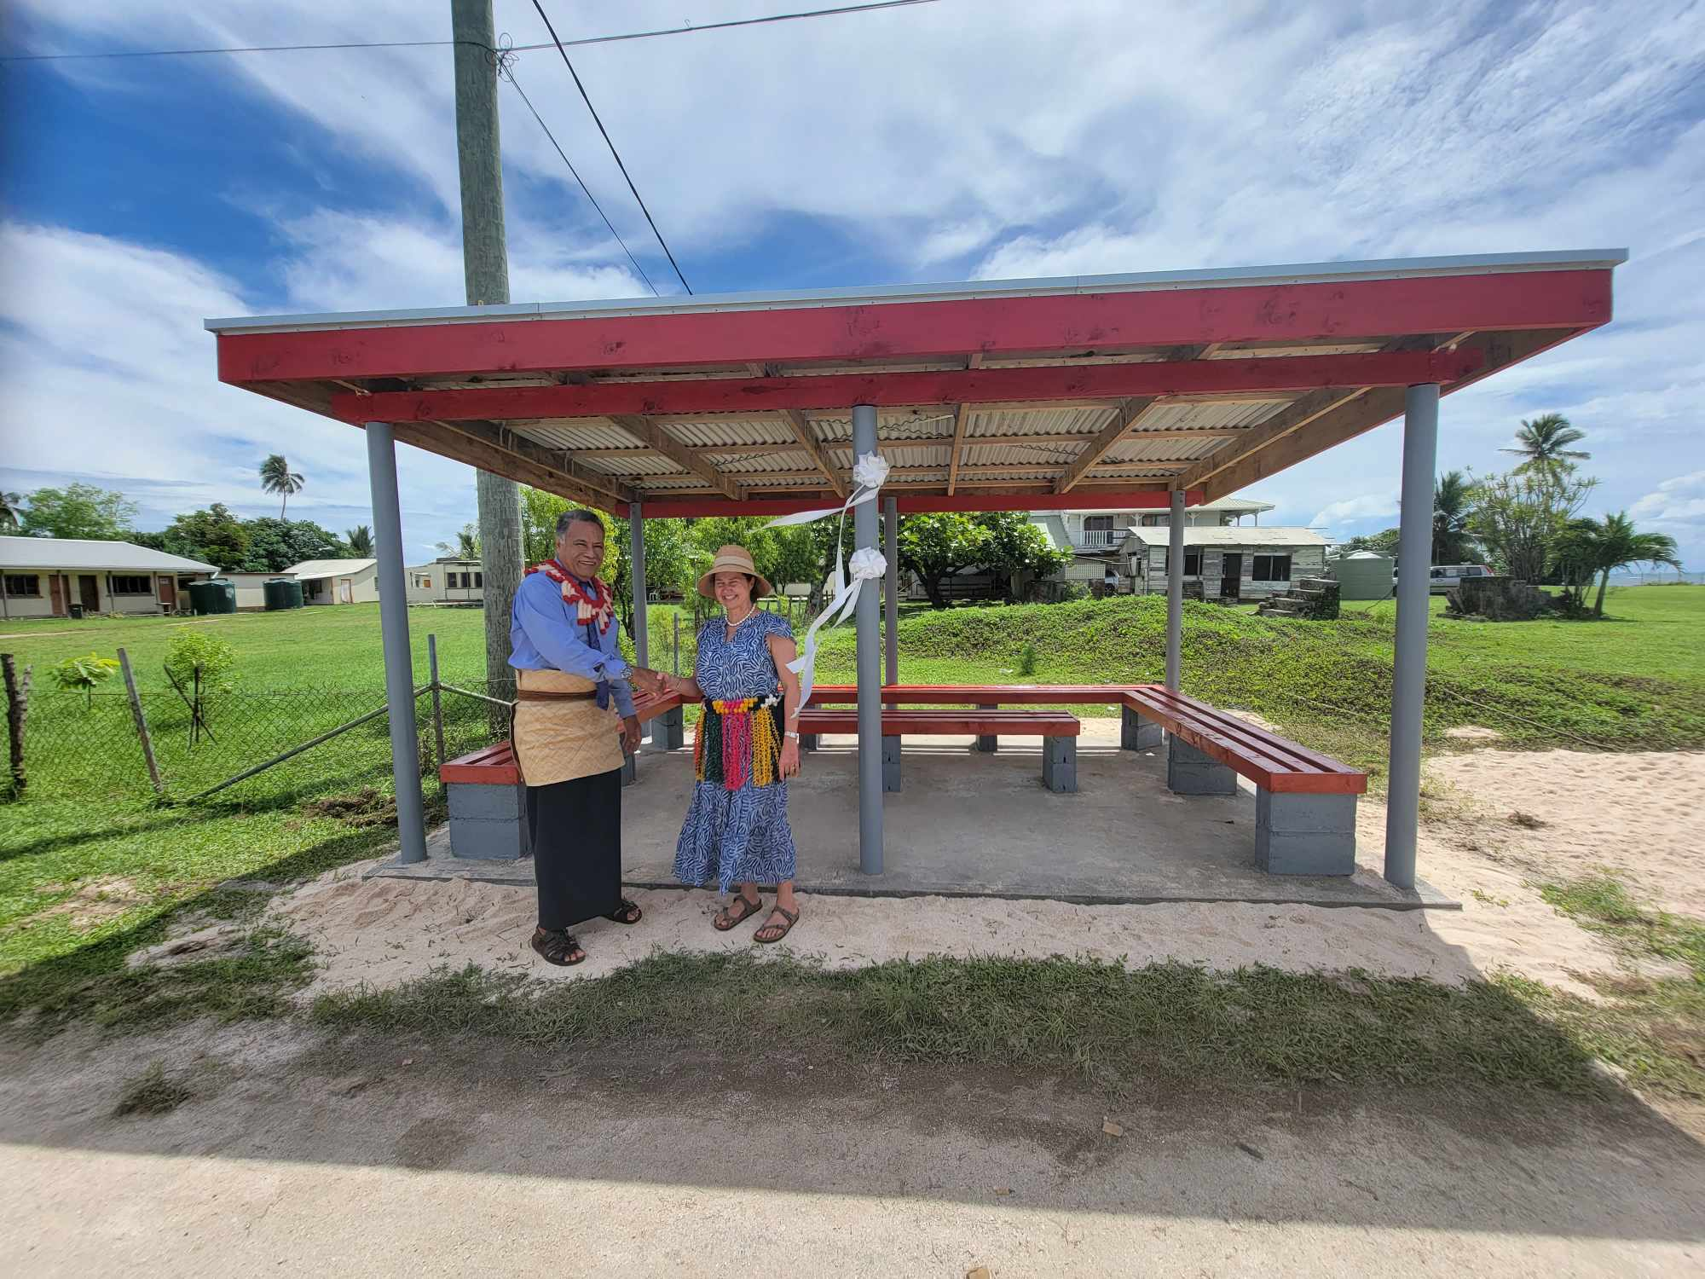

Bus Station at Ha’ato’u (Ha’apai) project, 2023